Calendar System
# Source: AI Source: Provided by: [Data Path: Persons Table -> ID Column: 1, Name_En Column: Motasem Essam] -> From: [ChatGPT] on [7/17/2026]
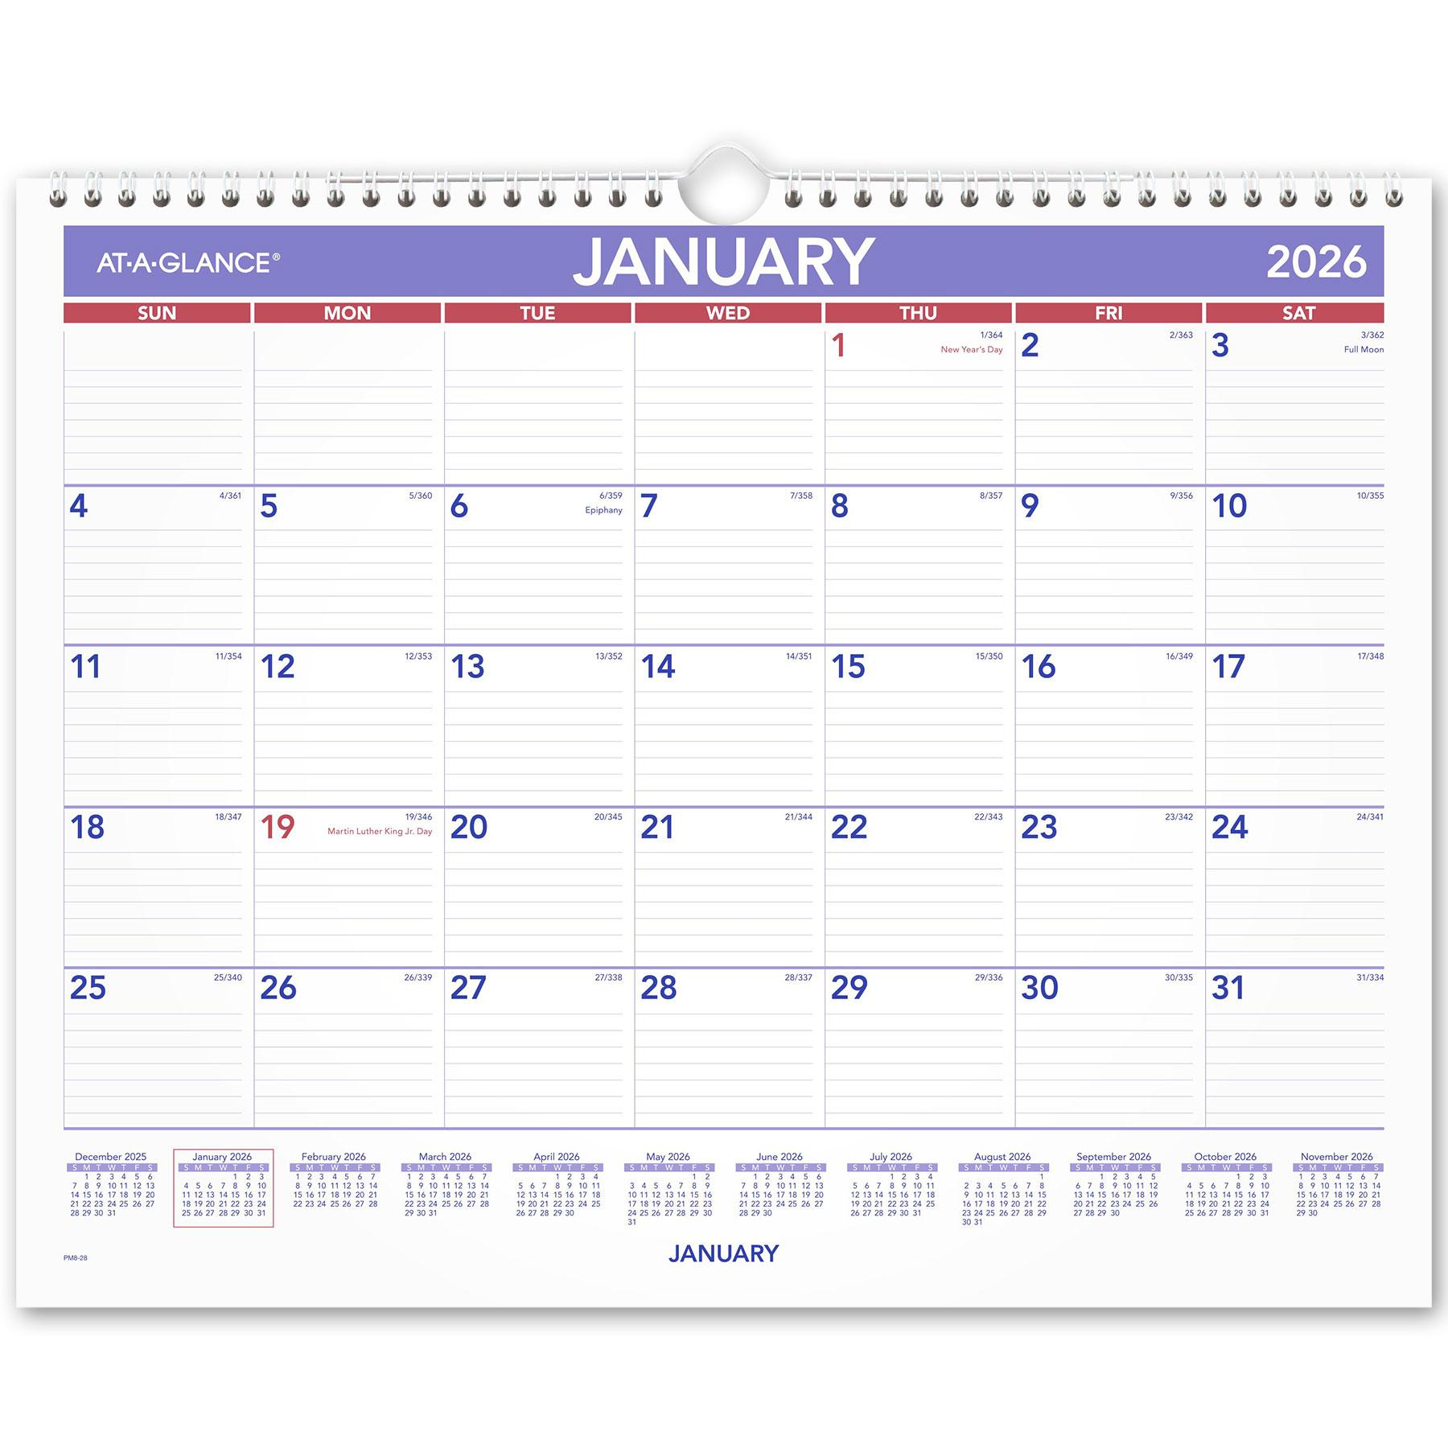
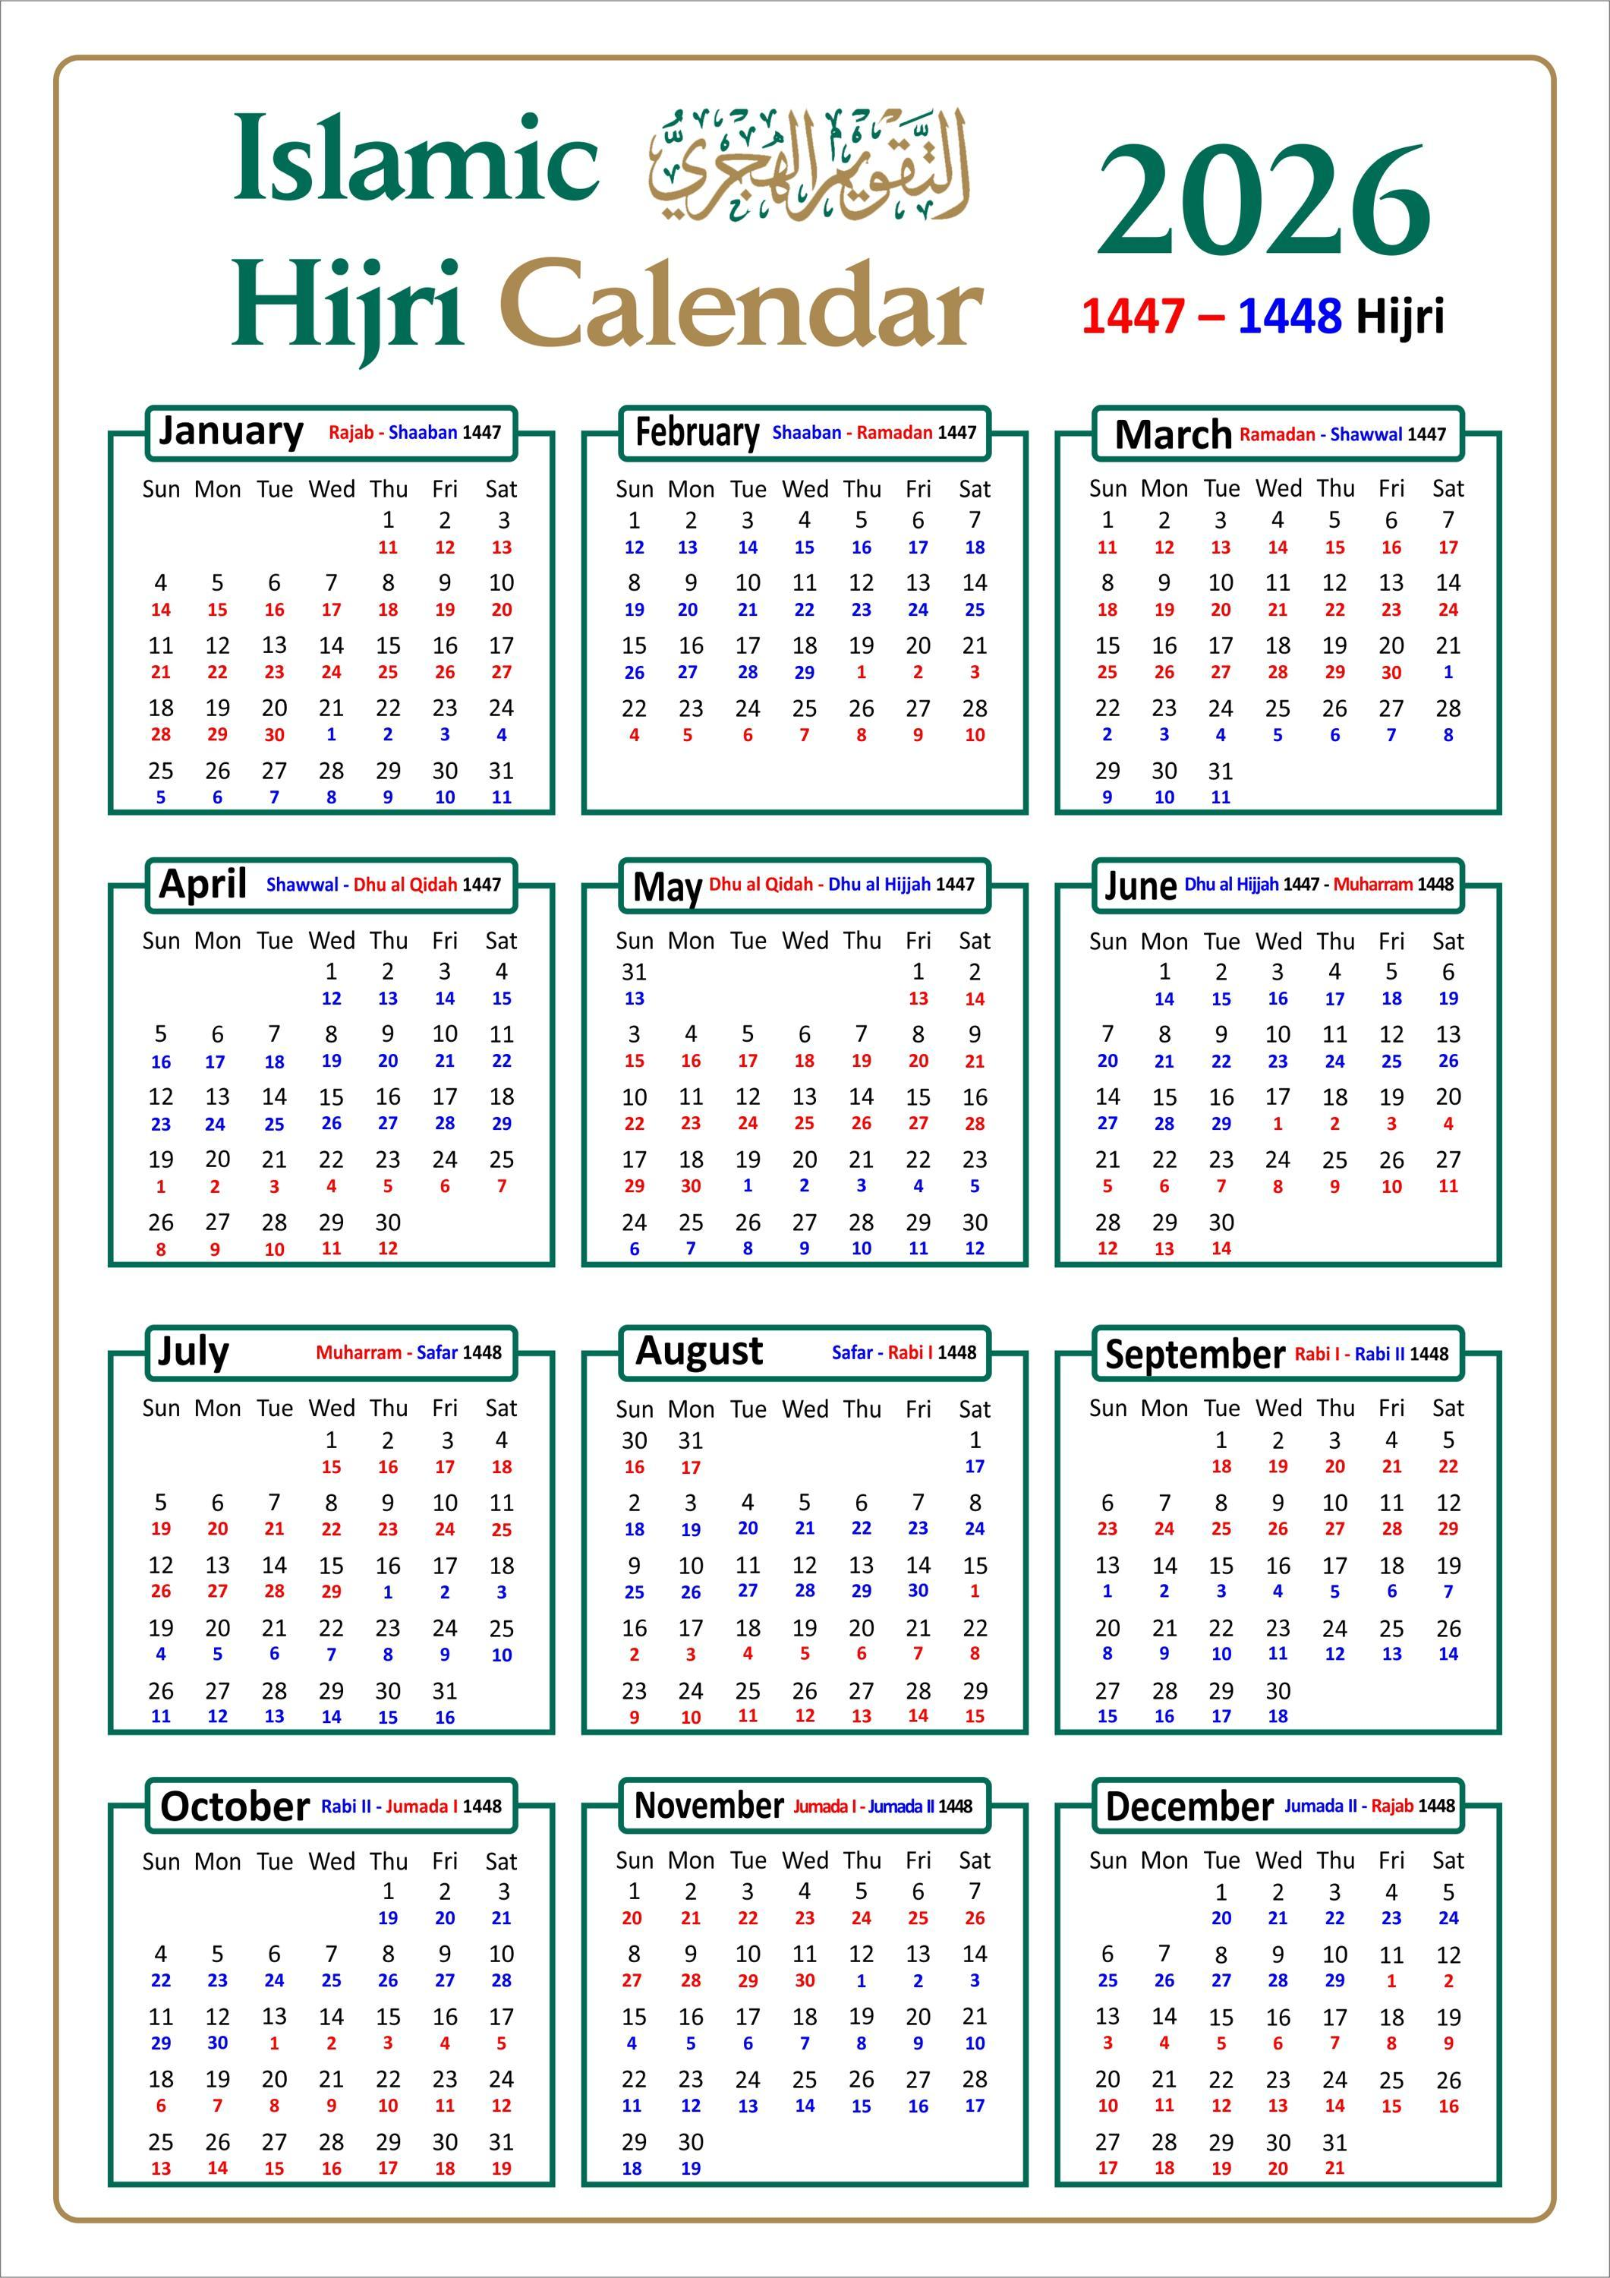
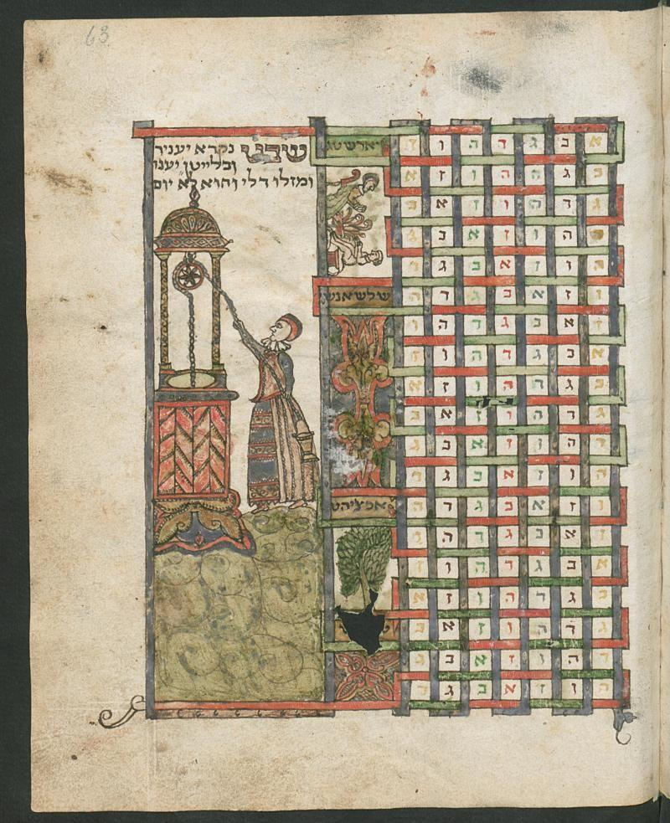
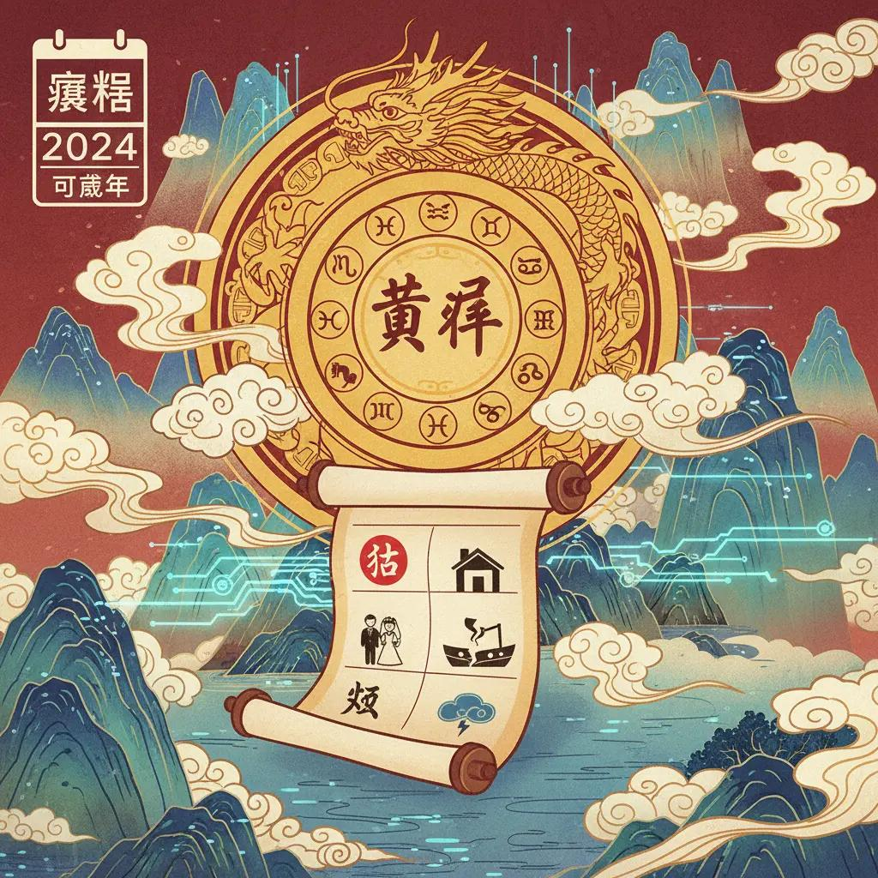
A Calendar System is a structured method of organizing days, weeks, months, and years to measure the passage of time. Calendar systems are based on recurring astronomical events such as the Earth's rotation, the Moon's phases, and the Earth's revolution around the Sun.
Calendar systems are essential for civil life, religion, agriculture, science, business, education, and historical record keeping.

Definition
# Source: AI Source: Provided by: [Data Path: Persons Table -> ID Column: 1, Name_En Column: Motasem Essam] -> From: [ChatGPT] on [7/17/2026]
A Calendar System is a method of dividing time into days, weeks, months, and years according to astronomical cycles and cultural or religious conventions.

Purpose
# Source: AI Source: Provided by: [Data Path: Persons Table -> ID Column: 1, Name_En Column: Motasem Essam] -> From: [ChatGPT] on [7/17/2026]
Calendar systems are used to:
- Organize days and years.
- Schedule events.
- Record history.
- Plan agricultural activities.
- Observe religious festivals.
- Manage business and government operations.
- Measure long periods of time.

Basic Components of a Calendar
Most calendar systems include:
- Day – the basic unit of time.
- Week – a group of days (commonly seven).
- Month – a division of the year.
- Year – a complete cycle of the calendar.
- Leap adjustment – additional days or months used to keep the calendar aligned with astronomical events.

Types of Calendar Systems
# Source: AI Source: Provided by: [Data Path: Persons Table -> ID Column: 1, Name_En Column: Motasem Essam] -> From: [ChatGPT] on [7/17/2026]
Calendar systems are generally classified according to the astronomical cycle they follow.

1. Solar Calendar
# Source: AI Source: Provided by: [Data Path: Persons Table -> ID Column: 1, Name_En Column: Motasem Essam] -> From: [ChatGPT] on [7/17/2026]
A Solar Calendar is based on the Earth's revolution around the Sun.
Characteristics
- Year length ≈ 365.2422 days
- Uses leap years to maintain accuracy.
- Closely follows the seasons.
Examples
- Gregorian Calendar
- Julian Calendar
- Persian (Solar Hijri) Calendar
Applications
- Civil use
- Government
- Education
- Business

2. Lunar Calendar
# Source: AI Source: Provided by: [Data Path: Persons Table -> ID Column: 1, Name_En Column: Motasem Essam] -> From: [ChatGPT] on [7/17/2026]
A Lunar Calendar is based on the phases of the Moon.
Characteristics
- Month length ≈ 29.5 days
- Year length ≈ 354 days
- Does not stay synchronized with the seasons unless adjusted.
Examples
- Islamic (Hijri) Calendar
Applications
- Religious observances
- Islamic festivals

3. Lunisolar Calendar
# Source: AI Source: Provided by: [Data Path: Persons Table -> ID Column: 1, Name_En Column: Motasem Essam] -> From: [ChatGPT] on [7/17/2026]
A Lunisolar Calendar combines lunar months with adjustments to remain aligned with the solar year.
Characteristics
- Months follow the Moon.
- Years remain synchronized with the seasons.
- Periodically adds a leap month.
Examples
- Hebrew Calendar
- Chinese Calendar
- Traditional Hindu Calendar
Applications
- Religious festivals
- Traditional celebrations

Major Calendar Systems

1. Gregorian Calendar
# Source: AI Source: Provided by: [Data Path: Persons Table -> ID Column: 1, Name_En Column: Motasem Essam] -> From: [ChatGPT] on [7/17/2026]
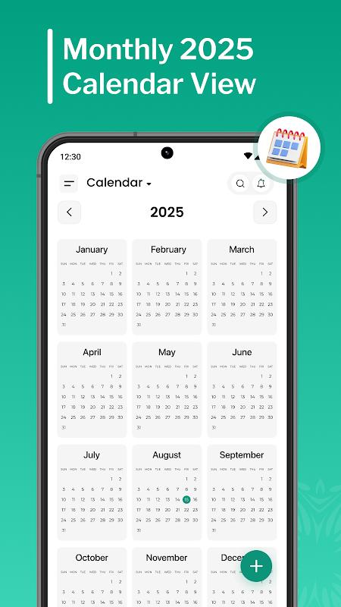
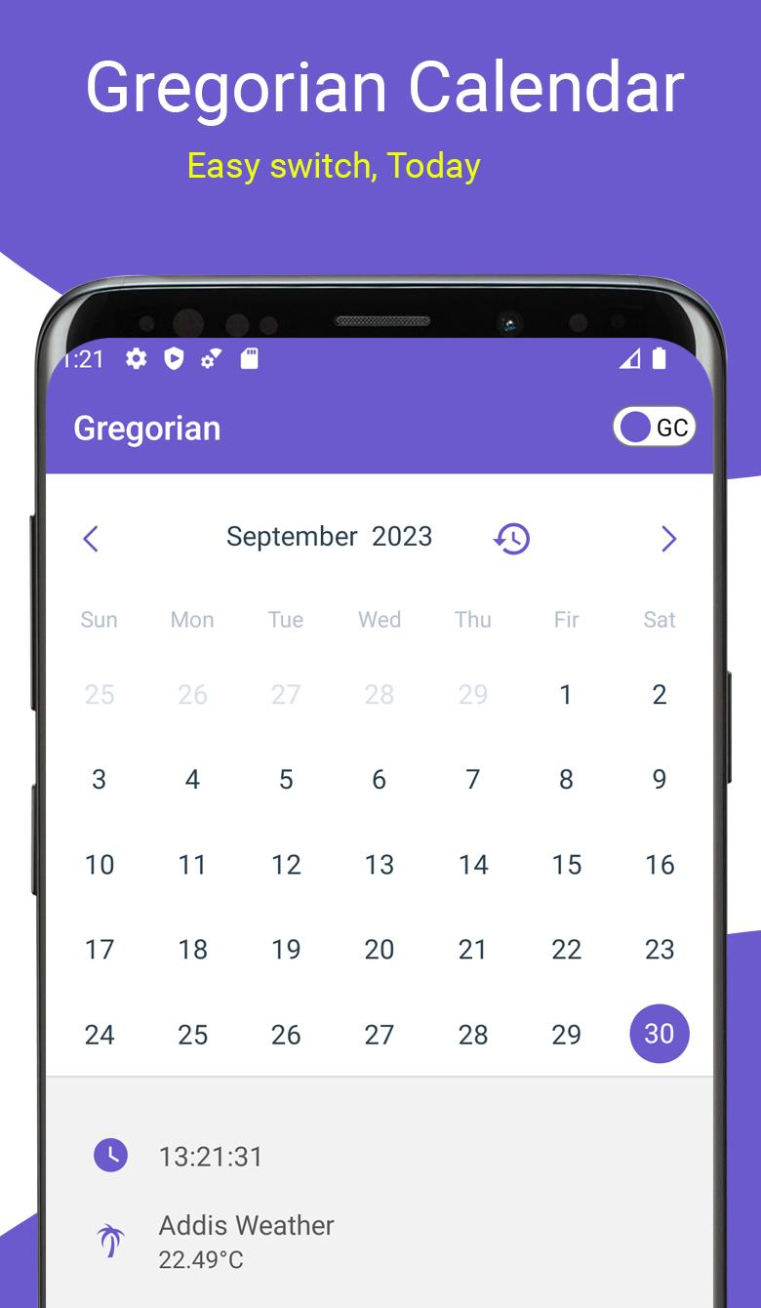
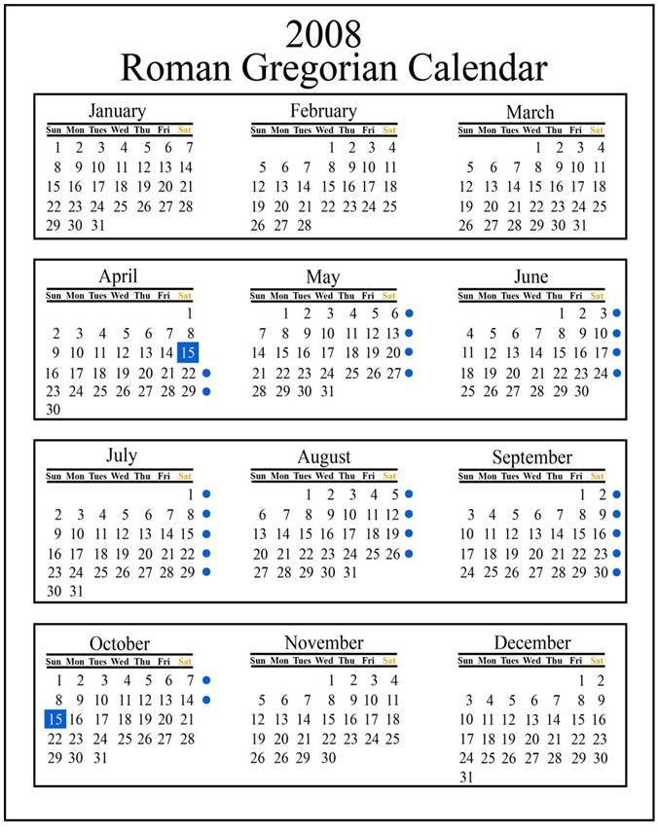
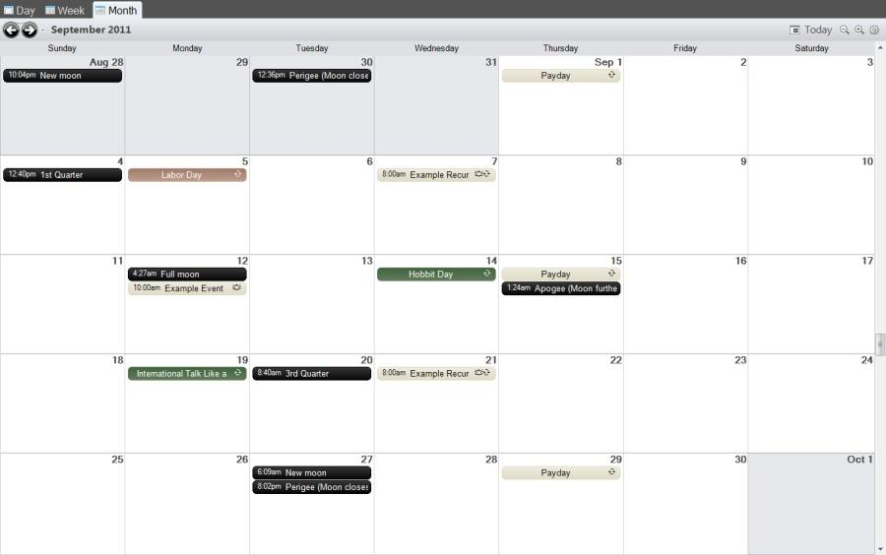
Introduced
1582 by Pope Gregory XIII.
Characteristics
- Solar calendar
- 365 days
- 366 days in leap years
- 12 months
Current Use
The most widely used civil calendar in the world.

2. Julian Calendar
# Source: AI Source: Provided by: [Data Path: Persons Table -> ID Column: 1, Name_En Column: Motasem Essam] -> From: [ChatGPT] on [7/17/2026]
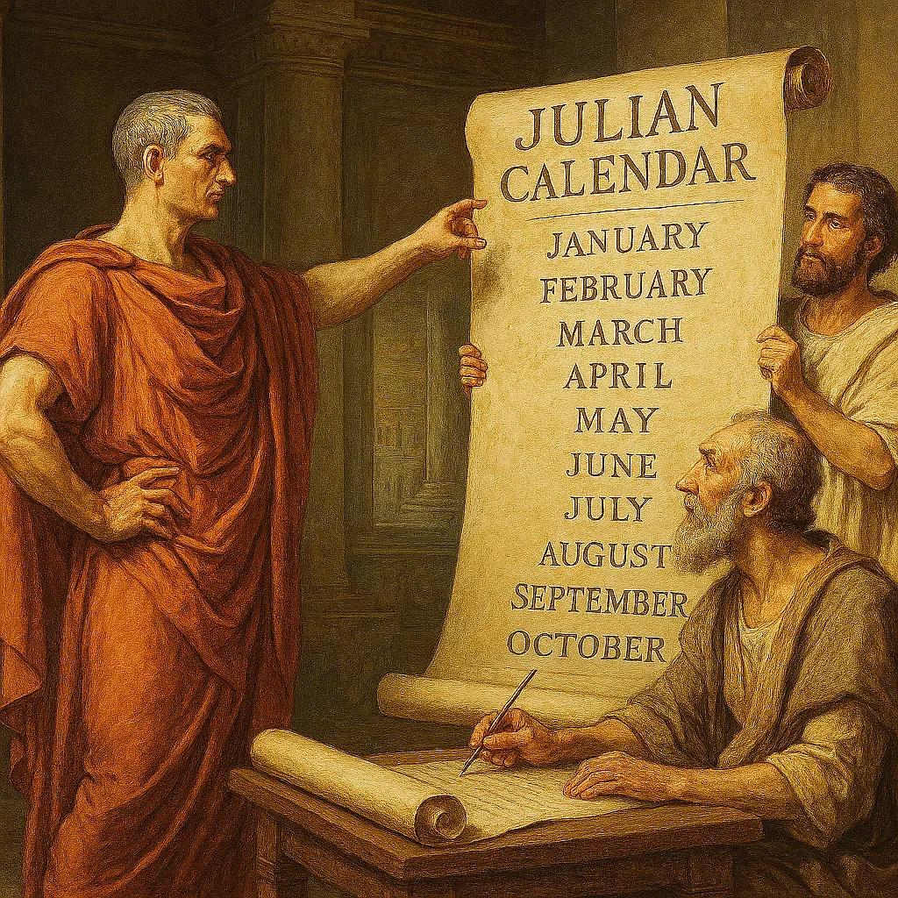
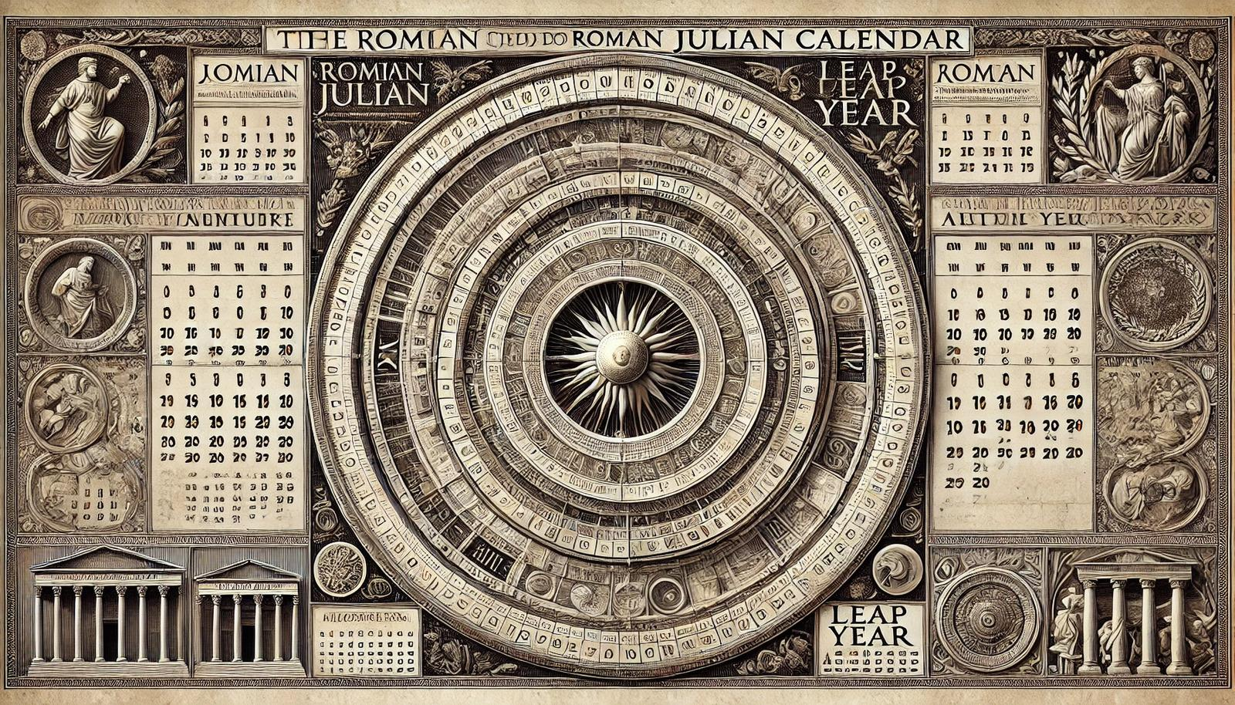
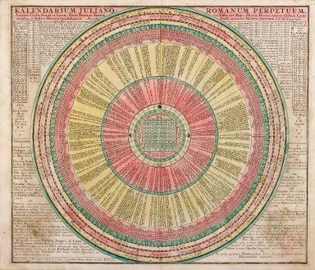
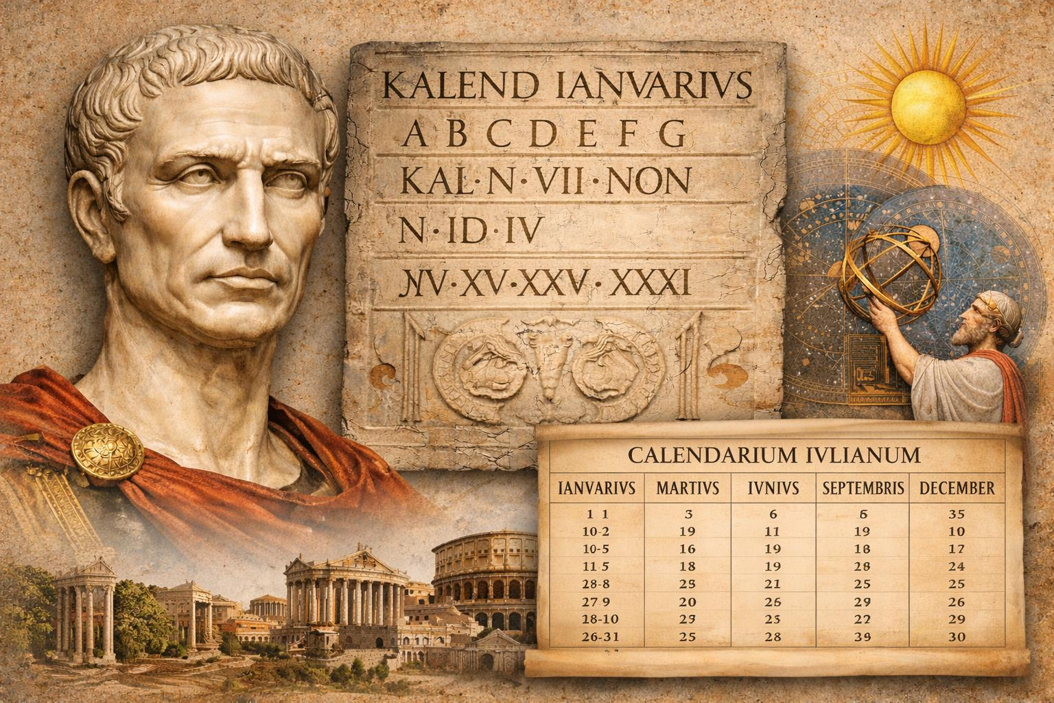
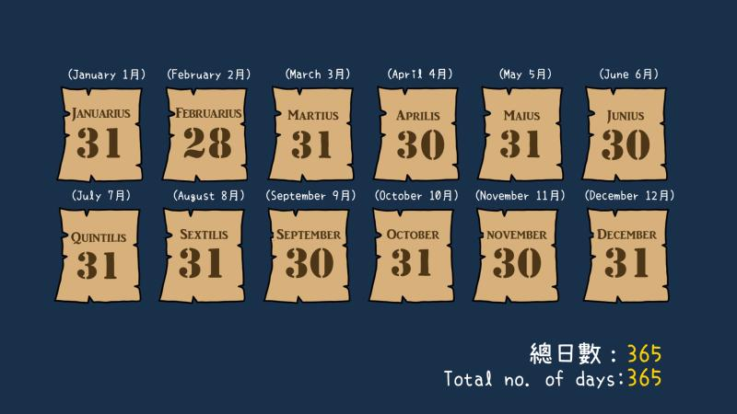
Introduced
45 BCE by Julius Caesar.
Characteristics
- Solar calendar
- Leap year every four years
- Average year = 365.25 days
Current Use
Still used by some Eastern Orthodox churches for religious observances.

3. Islamic (Hijri) Calendar
# Source: AI Source: Provided by: [Data Path: Persons Table -> ID Column: 1, Name_En Column: Motasem Essam] -> From: [ChatGPT] on [7/17/2026]

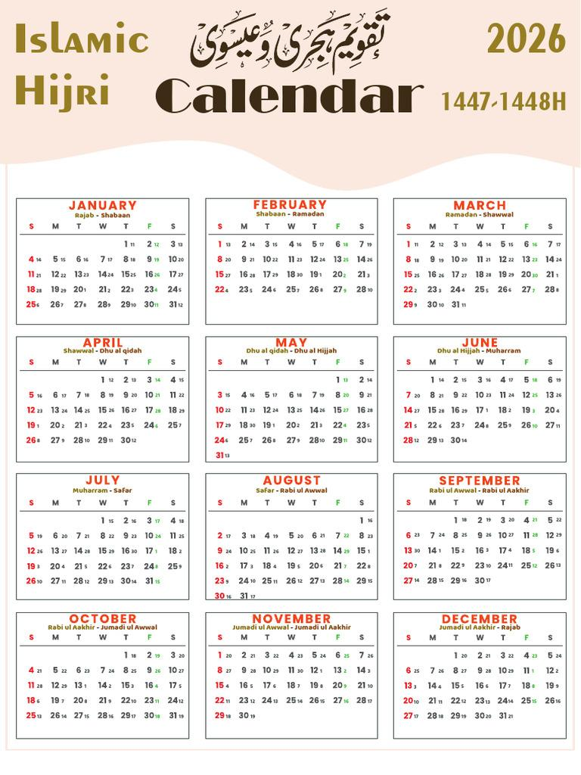
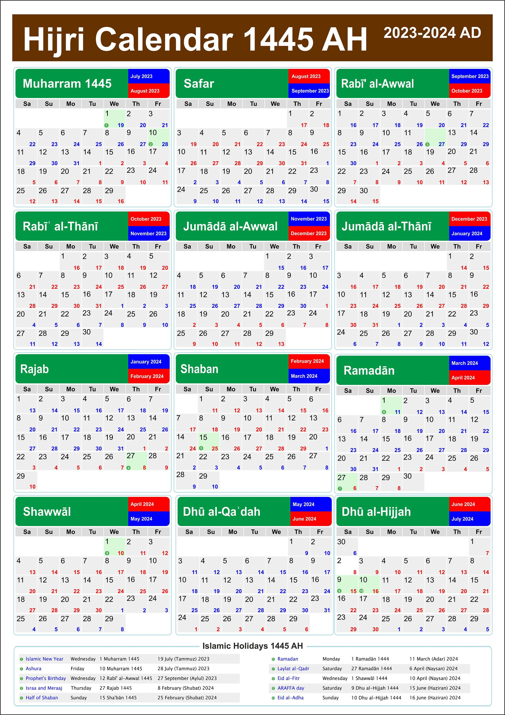
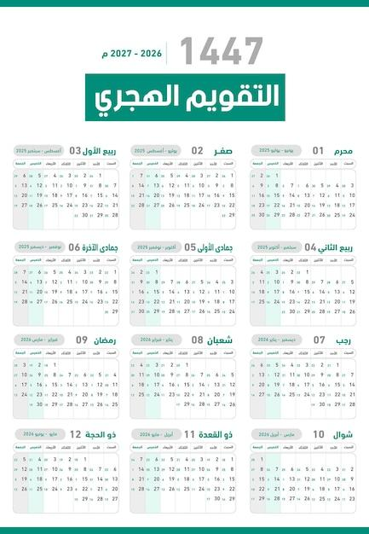
Characteristics
- Lunar calendar
- 12 lunar months
- About 354 or 355 days per year
Applications
- Islamic holidays
- Religious events
- Determining Ramadan and Hajj

4. Hebrew Calendar
# Source: AI Source: Provided by: [Data Path: Persons Table -> ID Column: 1, Name_En Column: Motasem Essam] -> From: [ChatGPT] on [7/17/2026]
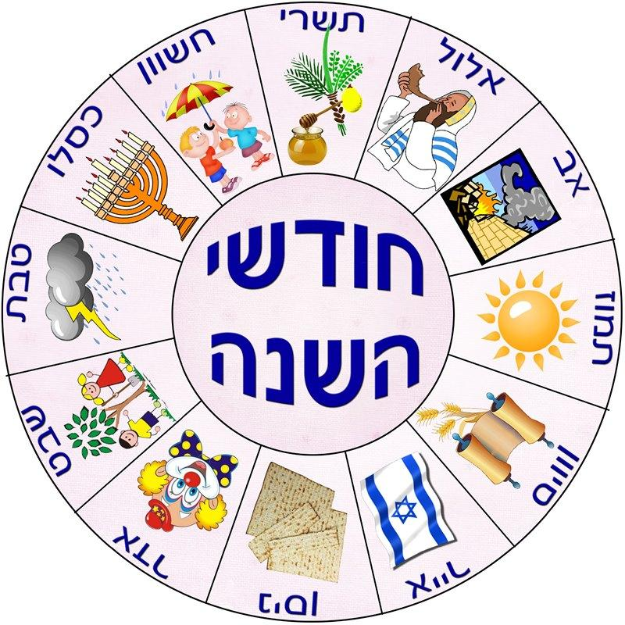
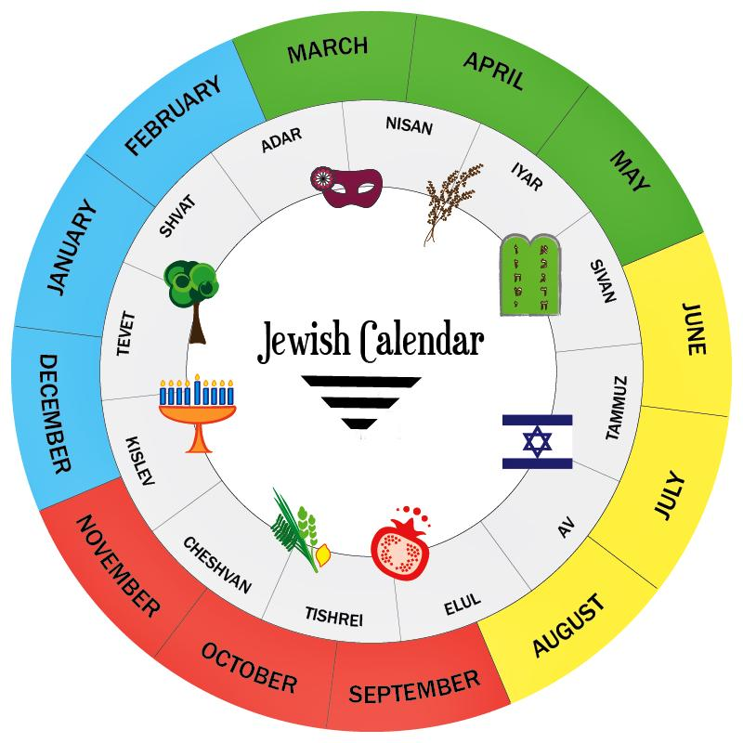
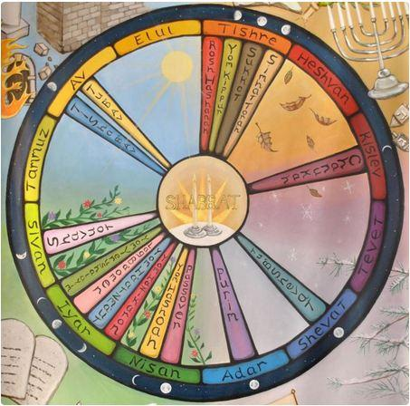
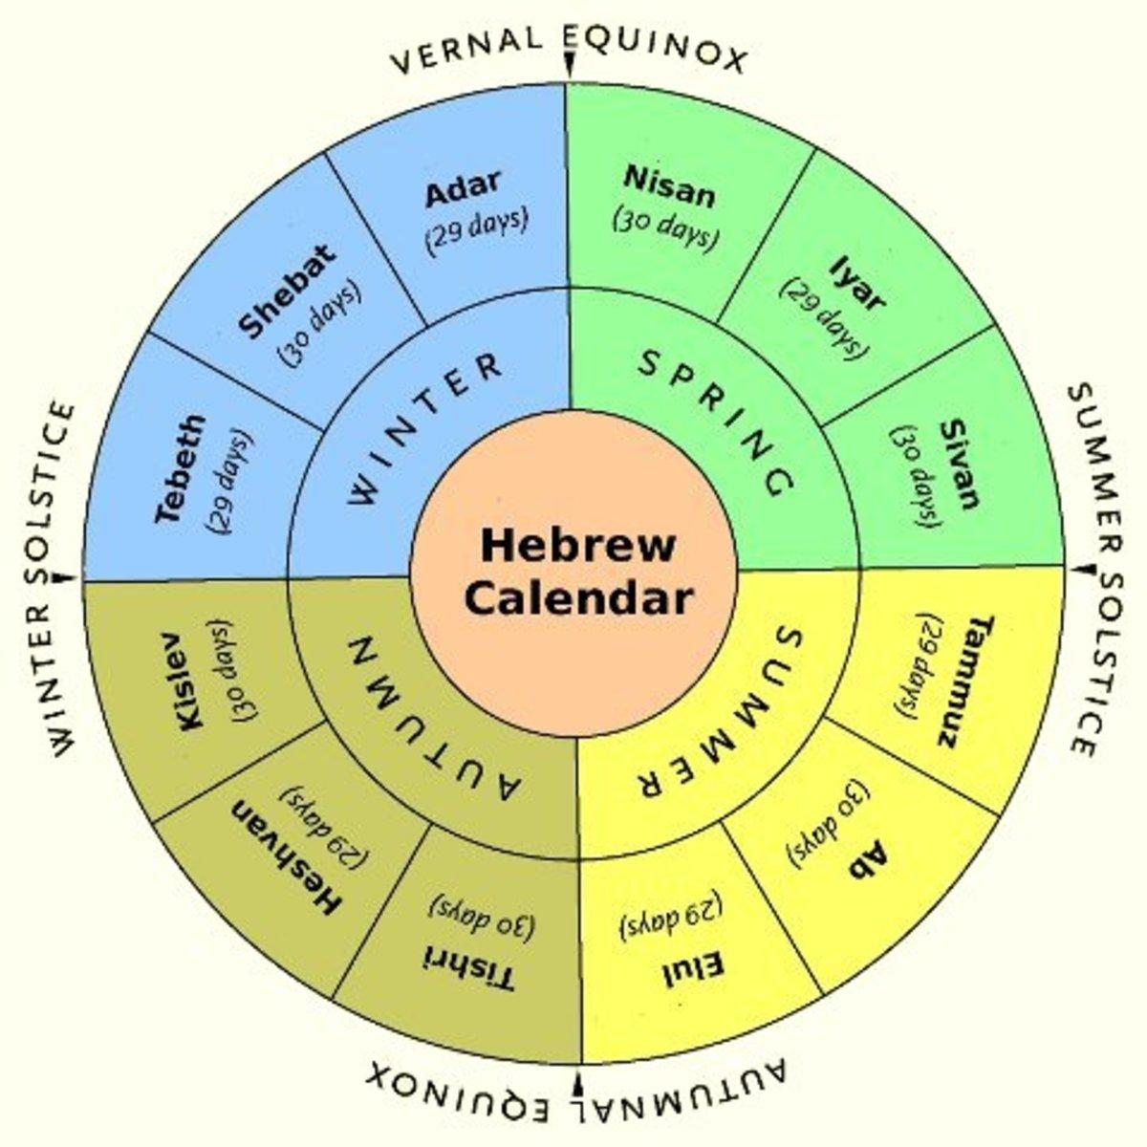
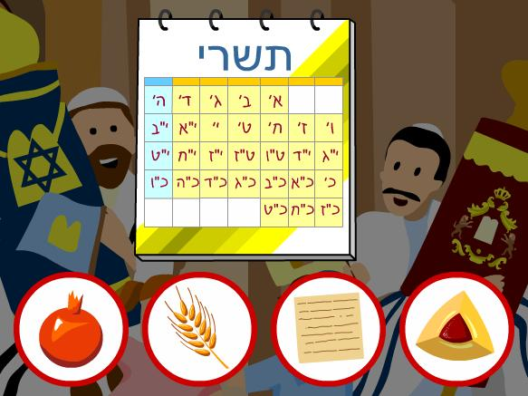
Characteristics
- Lunisolar calendar
- Leap months added periodically
- Keeps religious festivals in the same season
Applications
- Jewish religious observances

5. Chinese Calendar
# Source: AI Source: Provided by: [Data Path: Persons Table -> ID Column: 1, Name_En Column: Motasem Essam] -> From: [ChatGPT] on [7/17/2026]
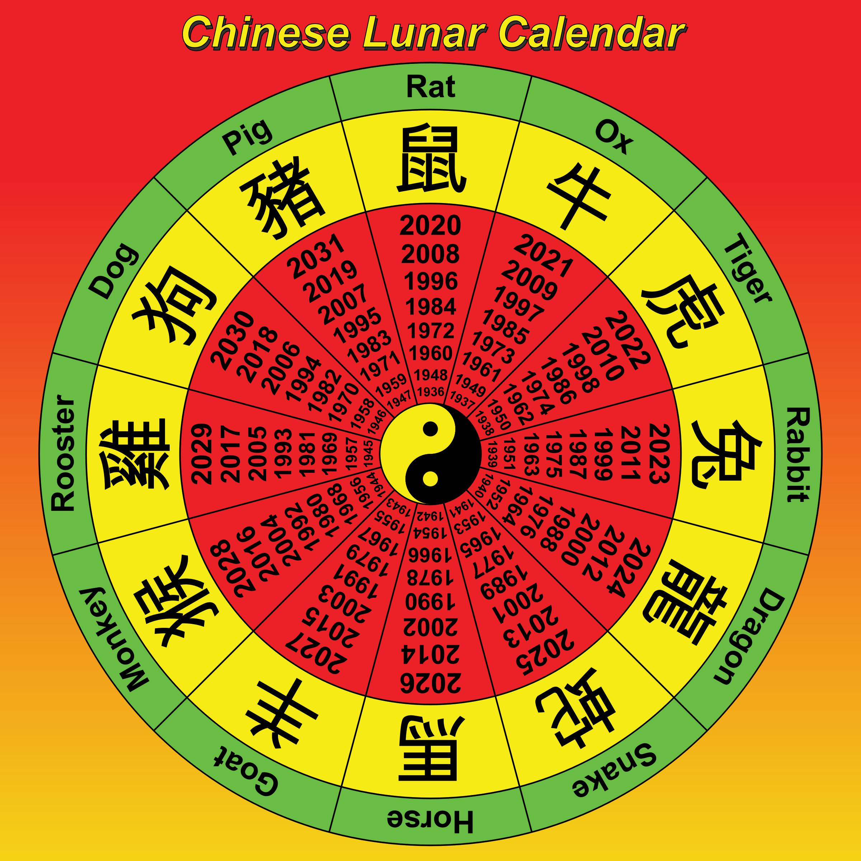
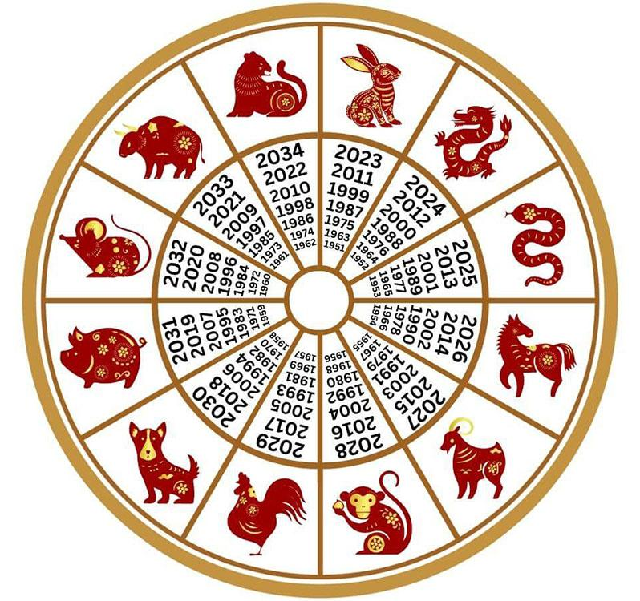
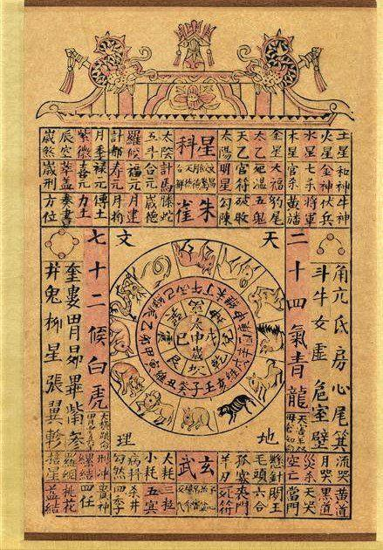
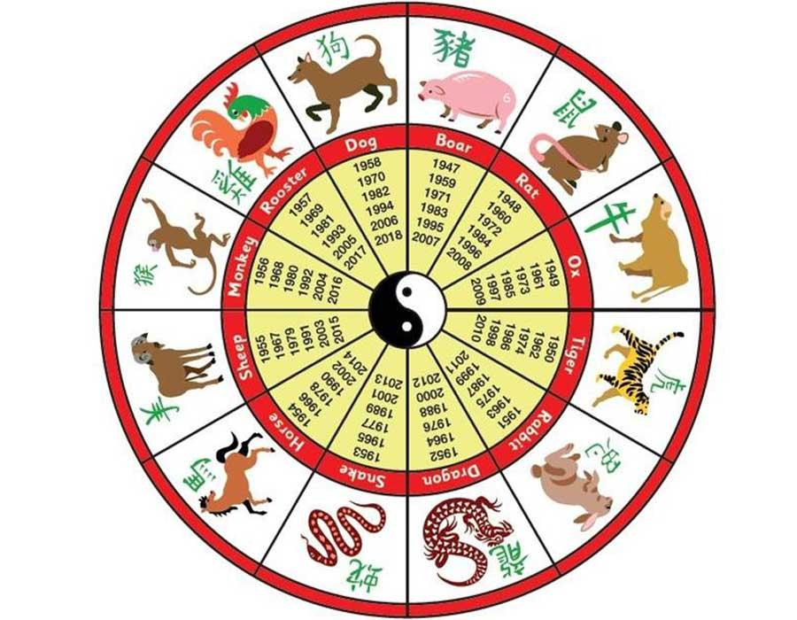
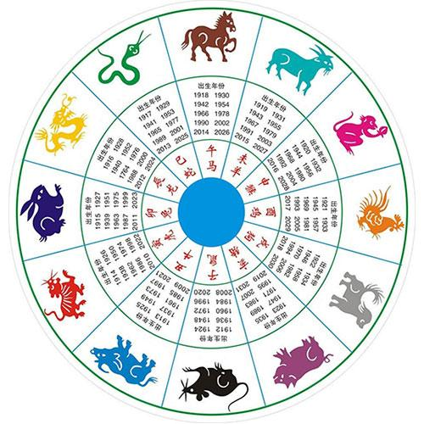
Characteristics
- Lunisolar calendar
- Includes leap months
- Uses a 12-animal zodiac cycle
Applications
- Chinese New Year
- Traditional festivals
- Cultural events

6. Persian (Solar Hijri) Calendar
# Source: AI Source: Provided by: [Data Path: Persons Table -> ID Column: 1, Name_En Column: Motasem Essam] -> From: [ChatGPT] on [7/17/2026]
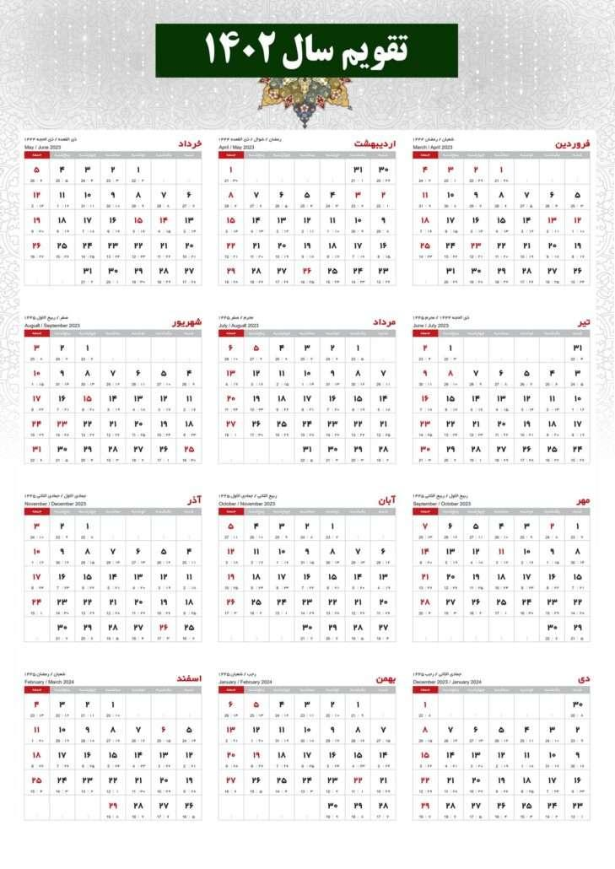
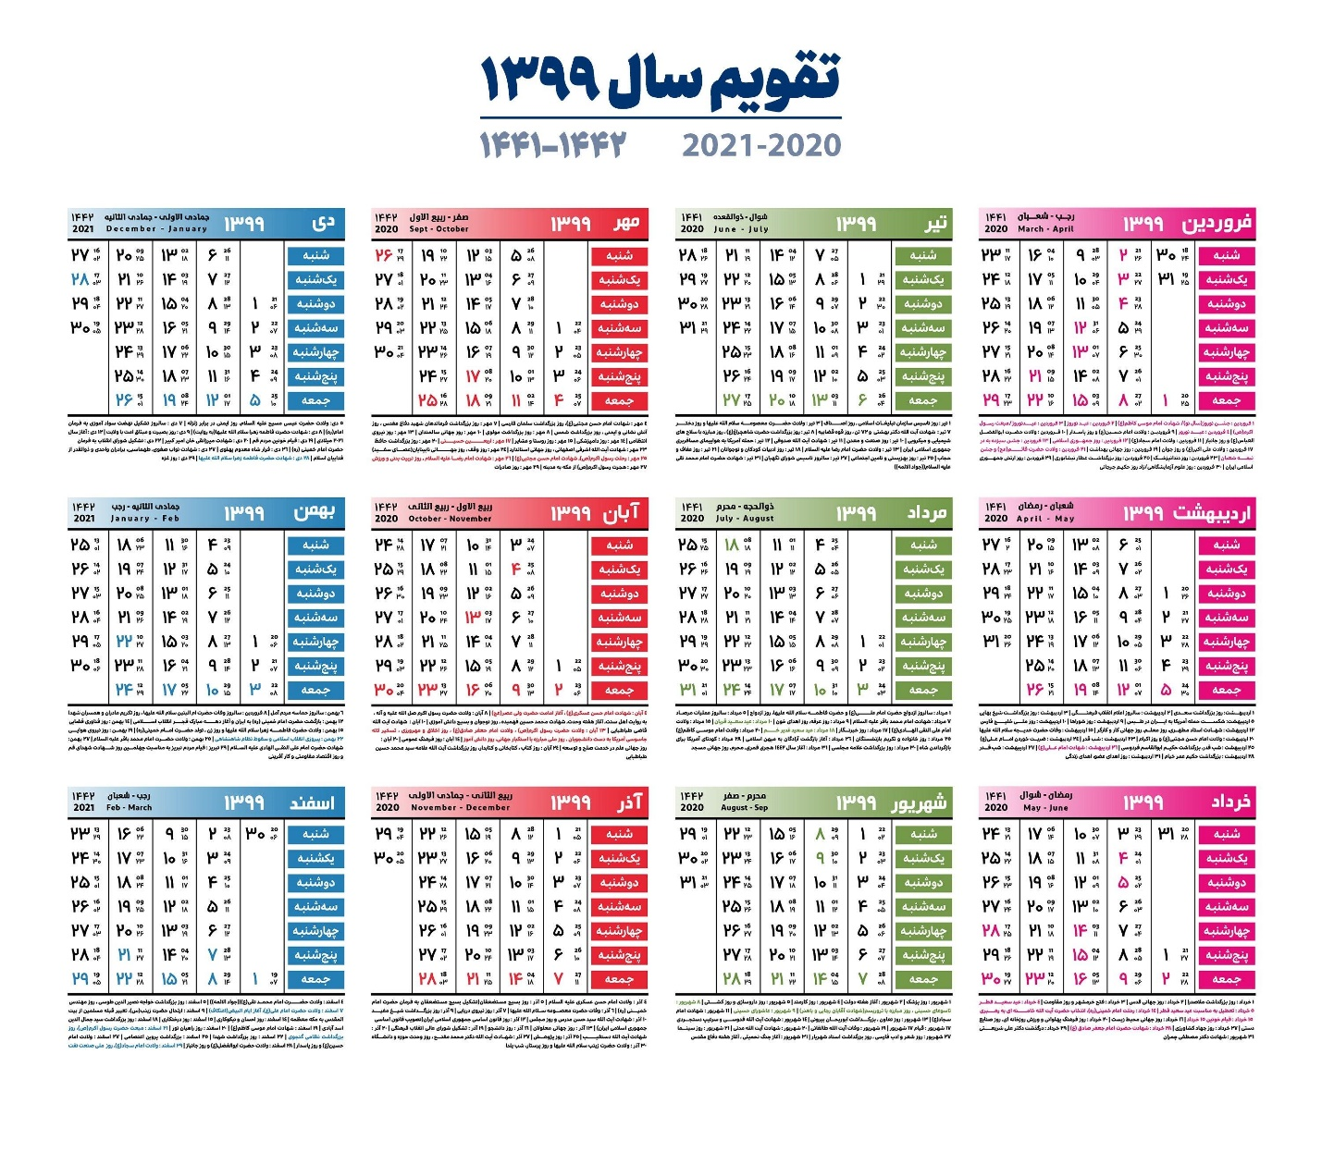
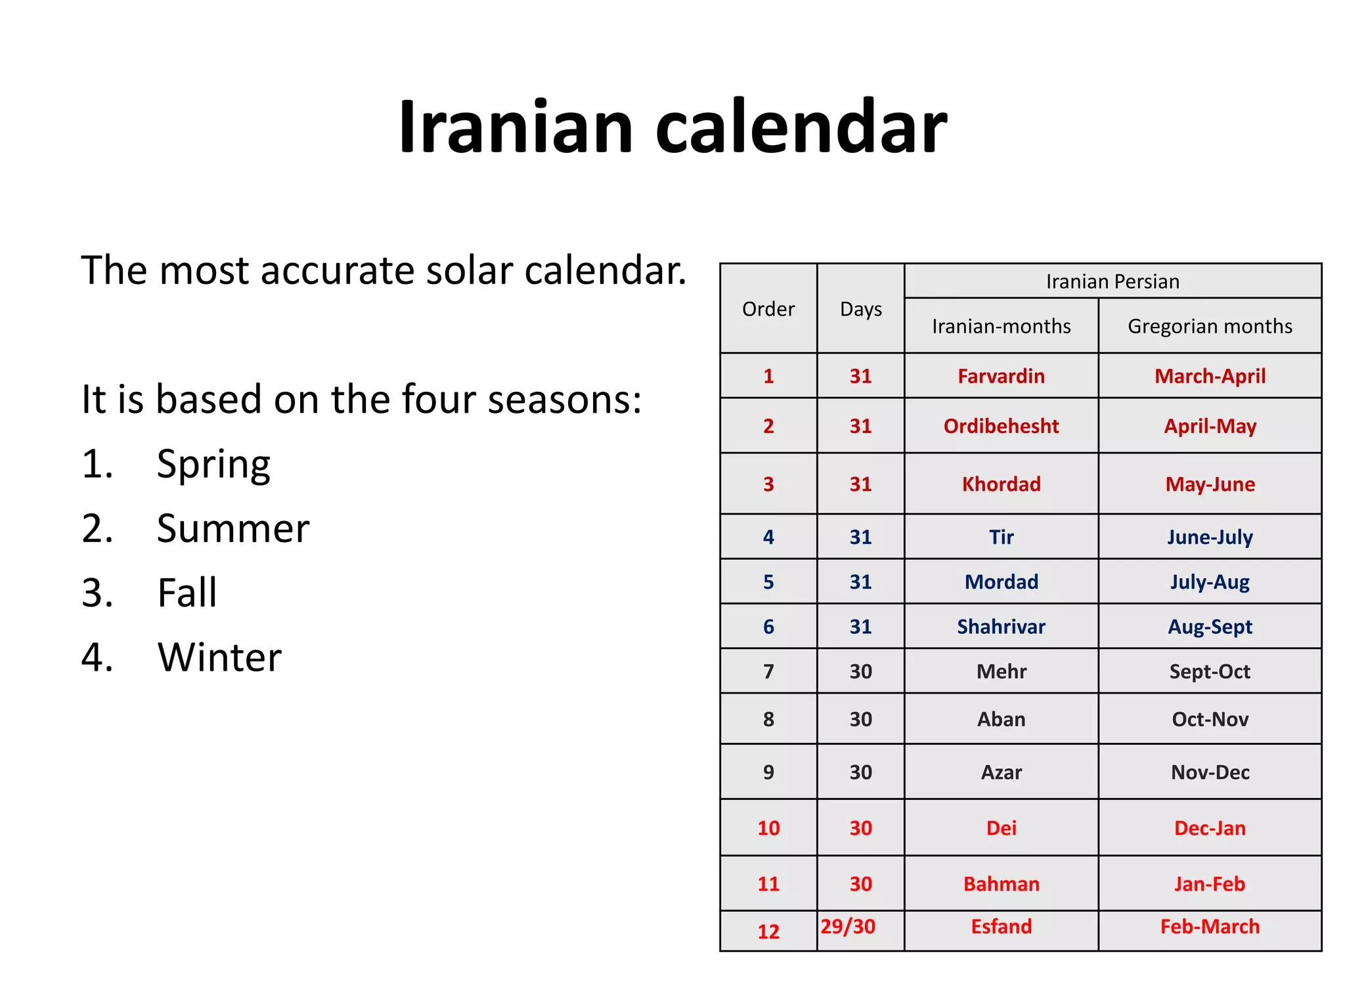
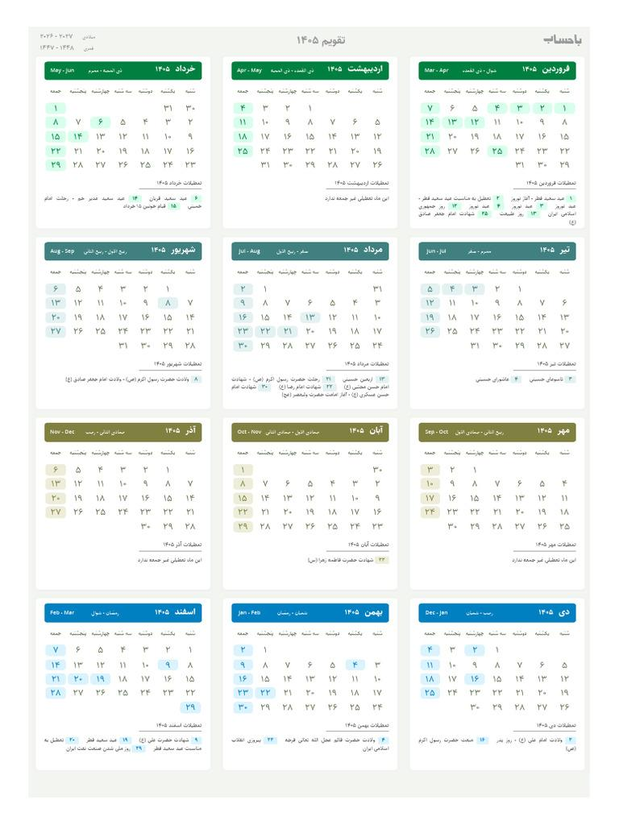
Characteristics
- Solar calendar
- Very accurate astronomical calculations
- Begins at the spring equinox
Applications
- Official calendar in Iran and Afghanistan

Comparison of Major Calendar Systems
# Source: AI Source: Provided by: [Data Path: Persons Table -> ID Column: 1, Name_En Column: Motasem Essam] -> From: [ChatGPT] on [7/17/2026]
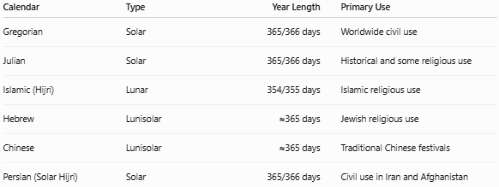
Calendar | Type | Year Length | Primary Use
Gregorian | Solar | 365/366 days | Worldwide civil use
Julian | Solar | 365/366 days | Historical and some religious use
Islamic (Hijri) | Lunar | 354/355 days | Islamic religious use
Hebrew | Lunisolar | ≈365 days | Jewish religious use
Chinese | Lunisolar | ≈365 days | Traditional Chinese festivals
Persian (Solar Hijri) | Solar | 365/366 days | Civil use in Iran and Afghanistan

Leap Year and Leap Month

Leap Year
# Source: AI Source: Provided by: [Data Path: Persons Table -> ID Column: 1, Name_En Column: Motasem Essam] -> From: [ChatGPT] on [7/17/2026]
Used in solar calendars to compensate for the Earth's orbit not being exactly 365 days.
Example:
- Gregorian Calendar adds 29 February in leap years.

Leap Month
# Source: AI Source: Provided by: [Data Path: Persons Table -> ID Column: 1, Name_En Column: Motasem Essam] -> From: [ChatGPT] on [7/17/2026]
Used in lunisolar calendars to keep lunar months aligned with the seasons.
Examples:
- Hebrew Calendar
- Chinese Calendar

Applications
# Source: AI Source: Provided by: [Data Path: Persons Table -> ID Column: 1, Name_En Column: Motasem Essam] -> From: [ChatGPT] on [7/17/2026]
Calendar systems are used in:
- Government
- Business
- Education
- Science
- Agriculture
- Religion
- Transportation
- Computing
- Historical research

Advantages
# Source: AI Source: Provided by: [Data Path: Persons Table -> ID Column: 1, Name_En Column: Motasem Essam] -> From: [ChatGPT] on [7/17/2026]
Calendar systems:
- Organize time efficiently.
- Standardize scheduling.
- Support historical documentation.
- Coordinate international activities.
- Align social and religious events.

Limitations
# Source: AI Source: Provided by: [Data Path: Persons Table -> ID Column: 1, Name_En Column: Motasem Essam] -> From: [ChatGPT] on [7/17/2026]
Different calendar systems can:
- Produce different year numbers.
- Cause confusion in international communication.
- Require conversions between systems.
- Vary in the dates of religious festivals.

Common Mistakes
# Source: AI Source: Provided by: [Data Path: Persons Table -> ID Column: 1, Name_En Column: Motasem Essam] -> From: [ChatGPT] on [7/17/2026]
- Assuming every calendar has 365 days.
- Confusing solar, lunar, and lunisolar calendars.
- Assuming New Year's Day is the same in all calendar systems.
- Ignoring leap years or leap months.

Key Points
# Source: AI Source: Provided by: [Data Path: Persons Table -> ID Column: 1, Name_En Column: Motasem Essam] -> From: [ChatGPT] on [7/17/2026]
- A Calendar System organizes time into days, weeks, months, and years.
- The three main categories are:
  - Solar Calendar
  - Lunar Calendar
  - Lunisolar Calendar
- The Gregorian Calendar is the world's standard civil calendar.
- Different calendar systems serve different civil, cultural, and religious purposes.

Conclusion
# Source: AI Source: Provided by: [Data Path: Persons Table -> ID Column: 1, Name_En Column: Motasem Essam] -> From: [ChatGPT] on [7/17/2026]
A Calendar System is a structured framework for measuring and organizing time based on astronomical cycles and cultural traditions. Solar calendars, such as the Gregorian Calendar, are designed to follow the Earth's orbit around the Sun and are used for most civil purposes. Lunar calendars, like the Islamic (Hijri) Calendar, follow the phases of the Moon, while lunisolar calendars, such as the Hebrew and Chinese calendars, combine lunar months with periodic adjustments to remain aligned with the seasons. Together, these systems support daily life, historical record keeping, scientific observation, agriculture, and religious practices around the world.

